CHAPTER THREE

SYSTEM ANALYSIS AND DESIGN

3.1 Introduction
This chapter presents the analysis and design of the Web-Based E-Post Management System. It describes the development methodology, analysis of the existing system, proposed system, system requirements, system users, system architecture, system models, database design, and security considerations.
The system is implemented using Node.js, Express.js, EJS, HTML, CSS, JavaScript, MongoDB, and Mongoose.

3.2 Development Methodology
The Waterfall Software Development Life Cycle (SDLC) model was adopted for the development of the system. The model follows a sequential approach consisting of requirements analysis, system design, implementation, testing, deployment, and maintenance.
Figure 3.1: Waterfall Software Development Model
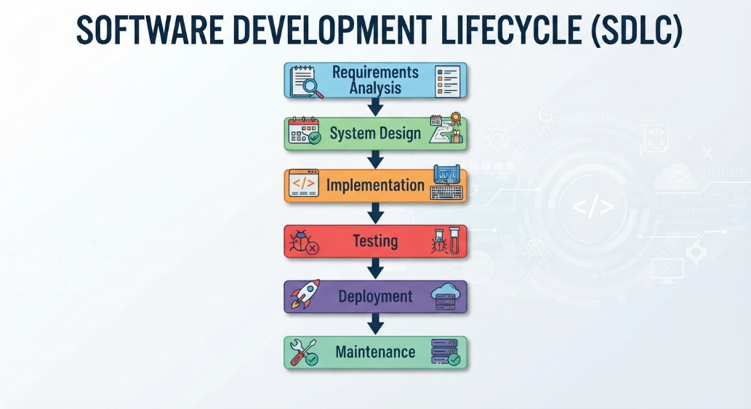
The methodology provides a structured approach for identifying requirements, designing the system, implementing the identified functions, and testing the completed application.

3.3 Analysis of the Existing System
The existing correspondence management process relies mainly on manual handling of incoming and outgoing documents. Documents are received, recorded, physically filed, forwarded to departments, processed, and eventually archived.
The major problems associated with the existing process include:
- Delay in document processing.
- Loss or misplacement of physical documents.
- Difficulty retrieving old correspondence.
- Poor monitoring of document movement.
- Excessive paperwork and storage requirements.
- Limited access control and accountability.
- Difficulty preparing reports manually.
- Limited notification and tracking capabilities.
These problems create the need for a centralized electronic correspondence management system.

3.4 Proposed System
The proposed Web-Based E-Post Management System is designed to manage organizational correspondence electronically. It provides facilities for registering, storing, assigning, routing, tracking, retrieving, and reporting correspondence.
The major functions of the system include:
- User authentication and access control.
- User and department management.
- Incoming and outgoing correspondence registration.
- Electronic document upload.
- Correspondence assignment and routing.
- Correspondence tracking.
- Notifications.
- Search and retrieval.
- Report generation.
- Activity recording.
The proposed system is intended to reduce dependence on paper-based processes and improve the accessibility, tracking, and management of correspondence.

3.5 System Users
The system supports four major categories of users:

Administrator
The administrator manages users, departments, roles, system activities, and reports.

Registry Officer
The Registry Officer registers incoming and outgoing correspondence, uploads documents, assigns correspondence, and monitors tracking information.

Department Officer
The Department Officer views assigned correspondence, processes documents, updates status, adds remarks, and forwards or completes correspondence.

Management User
Management users can view correspondence, monitor processing activities, and access relevant reports.

3.6 System Requirements

3.6.1 Functional Requirements
The system shall:
- Authenticate authorized users.
- Manage users and departments.
- Register incoming and outgoing correspondence.
- Upload electronic documents.
- Assign correspondence to users or departments.
- Forward correspondence between departments.
- Track correspondence movement and status.
- Update correspondence status.
- Generate notifications.
- Search and retrieve correspondence.
- Generate correspondence reports.
- Maintain activity records.

3.6.2 Non-Functional Requirements
The system should provide:
- Security: Authentication, authorization, password protection, and controlled document access.
- Usability: A simple and understandable user interface.
- Reliability: Consistent processing and storage of records.
- Performance: Reasonable response time under normal usage.
- Maintainability: A modular structure that allows future modification.
- Scalability: Ability to accommodate additional users and records.

3.7 System Architecture
The proposed system follows a web-based client-server architecture. Users access the system through a web browser. Requests are processed by the Node.js and Express.js application, while MongoDB provides data storage through Mongoose. EJS is used to generate dynamic web pages.
Figure 3.2: Proposed System Architecture
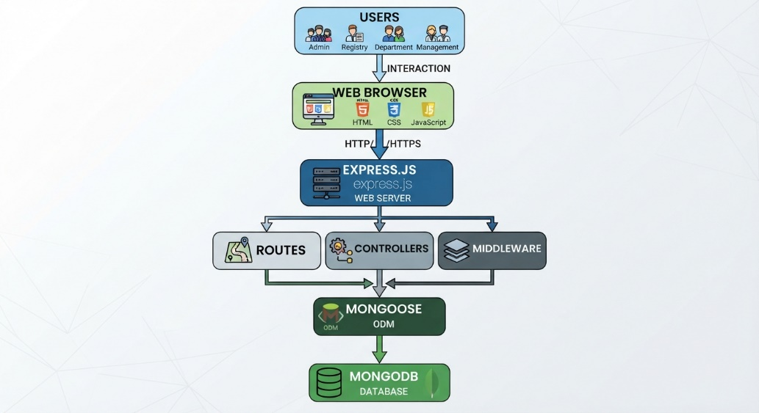

3.8 Use Case Model
The use case model illustrates the interaction between system users and the major functions of the system.
The main actors are Administrator, Registry Officer, Department Officer, and Management User.
The major use cases include login, user management, department management, correspondence registration, document upload, assignment, routing, tracking, notifications, search, and report generation.
Figure 3.3: Use Case Diagram
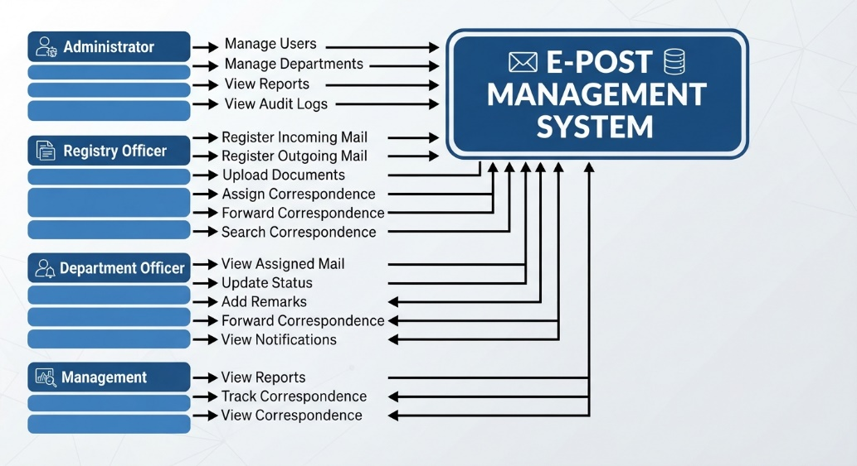

3.9 Data Flow Diagram
The Level 0 Data Flow Diagram represents the major processes and movement of information within the proposed system.
The major processes include:
- User Authentication.
- Correspondence Management.
- Document Management.
- Routing and Tracking.
- Notification Management.
- Reporting.
Figure 3.4: Level 0 Data Flow Diagram
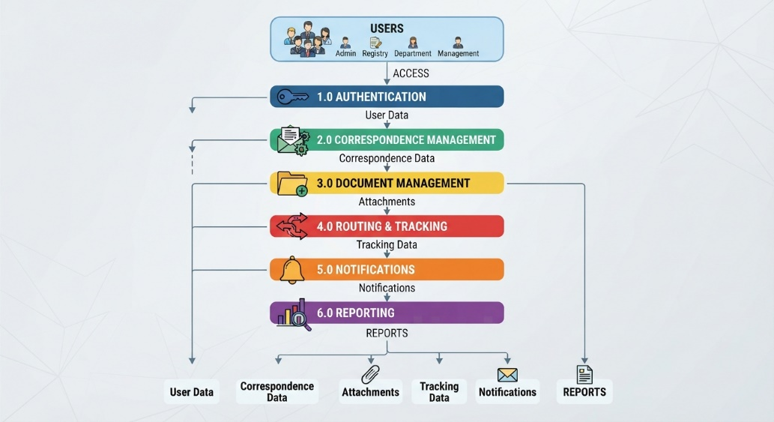

3.10 System Workflow
The general workflow of the system begins with user authentication. After login, users access functions according to their roles. Correspondence can then be registered, assigned, routed, processed, tracked, and completed.
Figure 3.5: System Workflow
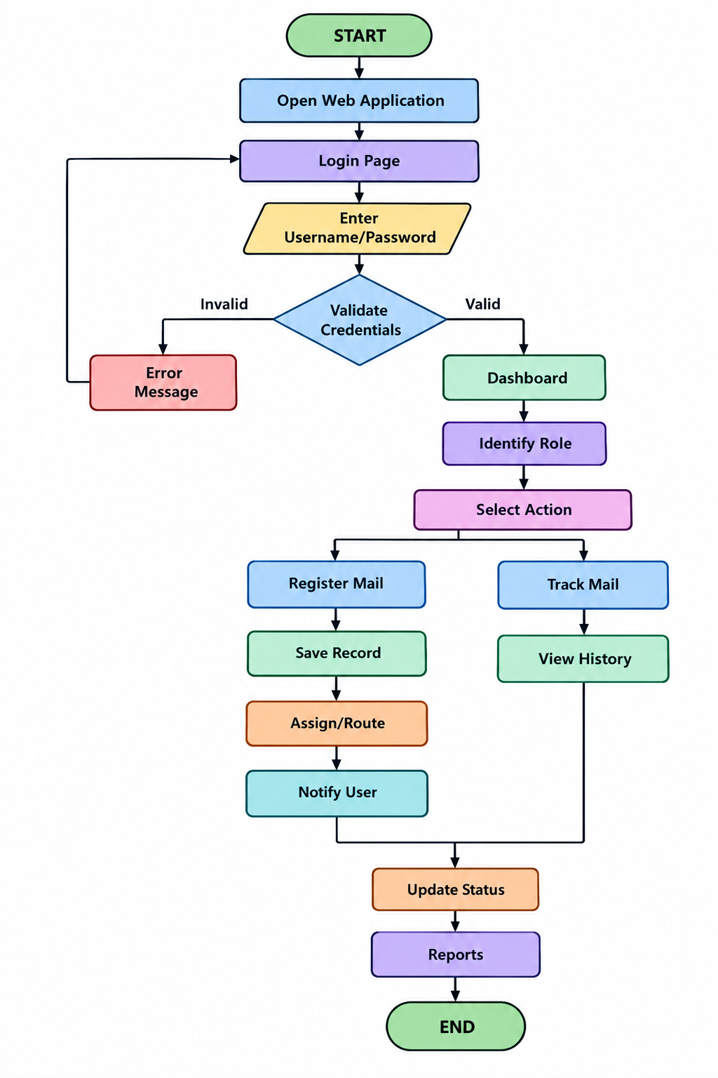

3.11 Database Design
MongoDB is used as the database management system. The major data collections correspond to the main entities of the application, including:
- Users
- Roles
- Departments
- Correspondence
- Attachments
- Tracking
- Notifications
- Audit Logs
Figure 3.6: Database/Data Relationship Model
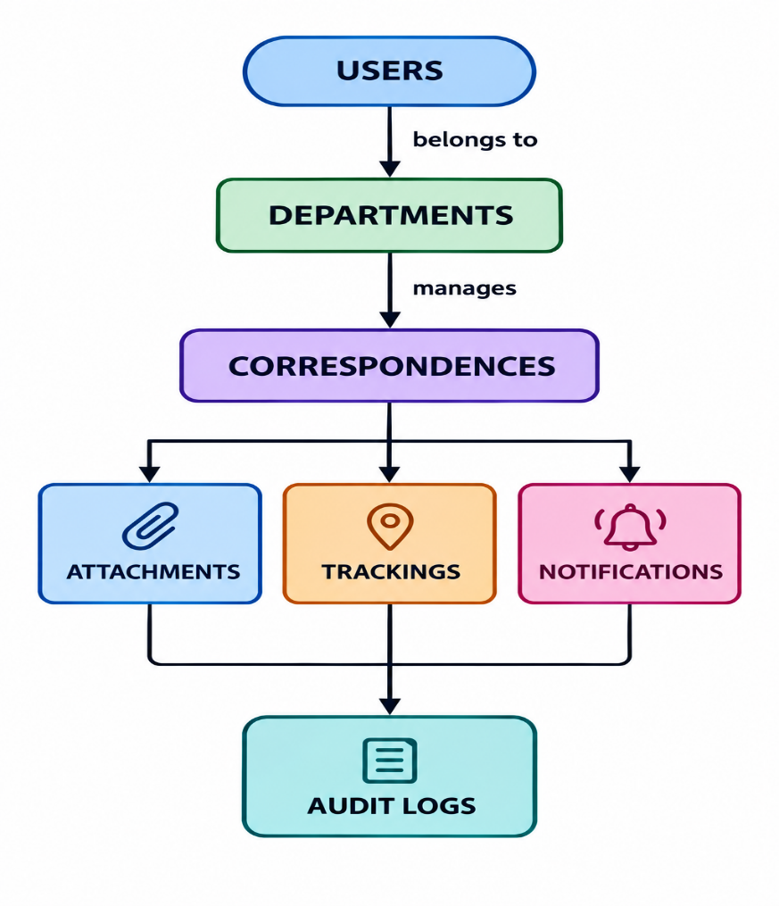
The database design supports the storage and retrieval of user, correspondence, tracking, notification, and administrative information.

3.12 Input and Output Design
The system provides input forms for user login, user registration, department management, and incoming and outgoing correspondence registration.
The main outputs include the dashboard, correspondence lists, correspondence details, tracking history, notifications, and reports.
The interface is designed to provide users with clear access to the functions required for managing correspondence.

3.13 Security Design
Security is incorporated through user authentication, password hashing, session management, role-based authorization, input validation, controlled document access, and audit logging.
Users are restricted to functions permitted by their assigned roles. This helps protect correspondence records and prevent unauthorized access.

